**Ashutosh Jha**

**11811**

**Case Study 9 - CPM Estimation**

***A.1:***

1. Critical Path is highlighted in color in the figure given below:

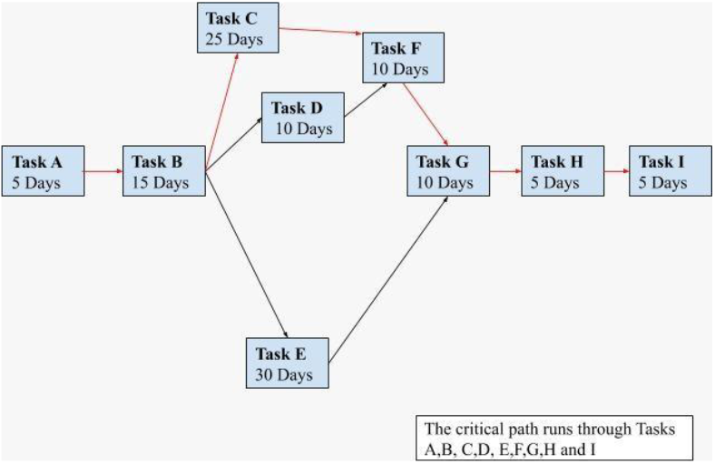

1. The sum of the critical task duration is 75 days & therefore, the planned duration of the project is 15 weeks.
2. Task D is non-critical with 10 days (2 weeks) float Task E is non-critical with 5 days (1 week) float Award 1 mark for identifying each task and 1 mark for the correct calculation of float in each case.

